Practical No: 3
Programs related to different Layouts
A)Linear Layaout
Code of MainActivity.kt:
<?xml version="1.0" encoding="utf-8"?>
<LinearLayout xmlns:android="http://schemas.android.com/apk/res/android"
xmlns:app="http://schemas.android.com/apk/res-auto"
xmlns:tools="http://schemas.android.com/tools"
android:layout_width="match_parent"
android:orientation="vertical"
android:layout_height="match_parent">
<TextView
android:layout_width="match_parent"
android:layout_height="wrap_content"
android:id="@+id/textView"
android:textAlignment="textEnd"
android:textSize="30dp"
android:layout_margin="2dp"
android:gravity="end"/>
<GridLayout
android:layout_width="match_parent"
android:layout_height="match_parent"
android:columnCount="4"
android:rowCount="5"
android:layout_margin="2dp">
<Button
android:id="@+id/button"
android:text="1"
android:layout_margin="8dp"/>
<Button
android:id="@+id/button2"
android:text="2"
android:layout_margin="8dp"/>
<Button
android:id="@+id/button3"
android:text="3"
android:layout_margin="8dp"/>
</GridLayout>
</LinearLayout>

mainActivity:
package com.example.practical1
import android.graphics.Color
import androidx.appcompat.app.AppCompatActivity
import android.os.Bundle
import android.widget.Toast
import kotlinx.android.synthetic.main.activity_main.*
class MainActivity : AppCompatActivity() {
override fun onCreate(savedInstanceState: Bundle?) {
super.onCreate(savedInstanceState)
setContentView(R.layout.activity_main)
var rhs=0
var lhs=0
var result=0
var operator=""
button.setOnClickListener {
textView.append("1")
}
button2.setOnClickListener {
textView.append("2")
}
button3.setOnClickListener {
textView.append("3")
}
button4.setOnClickListener {
textView.append("4")
}
button5.setOnClickListener {
textView.append("5")
}
button6.setOnClickListener {
textView.append("6")
}
button7.setOnClickListener {
textView.append("7")
}
button8.setOnClickListener {
textView.append("8")
}
button9.setOnClickListener {
textView.append("9")
}
button11.setOnClickListener {
rhs = textView.text.toString().toInt()
Toast.makeText(this, rhs.toString(), Toast.LENGTH_SHORT).show()
textView.text = ""
operator = "+"
}
button12.setOnClickListener {
rhs = textView.text.toString().toInt()
Toast.makeText(this, rhs.toString(), Toast.LENGTH_SHORT).show()
textView.text = ""
operator = "-"
}
button13.setOnClickListener {
rhs = textView.text.toString().toInt()
Toast.makeText(this, rhs.toString(), Toast.LENGTH_SHORT).show()
textView.text = ""
operator = "*"
}
button14.setOnClickListener {
rhs = textView.text.toString().toInt()
Toast.makeText(this, rhs.toString(), Toast.LENGTH_SHORT).show()
textView.text = ""
operator = "/"
}
button15.setOnClickListener {
lhs = textView.text.toString().toInt()
Toast.makeText(this, lhs.toString(), Toast.LENGTH_SHORT).show()
if (operator=="+") {
result =rhs+lhs}
if (operator=="-") {
result =rhs-lhs }
if (operator=="*") {
result =rhs*lhs }
if (operator=="/") {
result =rhs/lhs}
textView.text =result.toString()
}
button16.setOnClickListener {
rhs=0
lhs=0
textView.text=""
}}}

Output:
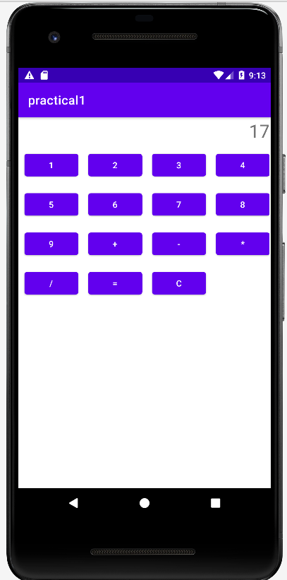
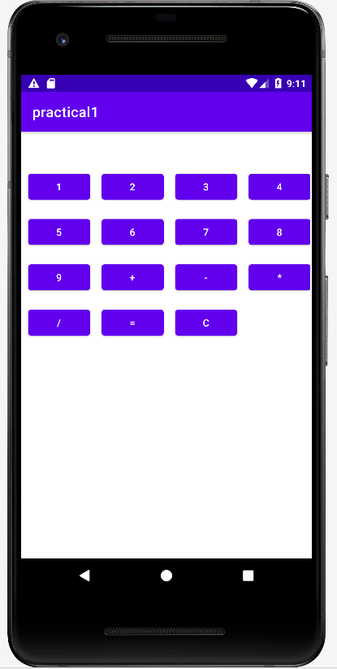

B)List View
Code of MainActivity.kt:

mainActivity:

package srm.it.list_radio
import android.graphics.Color
import androidx.appcompat.app.AppCompatActivity
import android.os.Bundle
import android.widget.ArrayAdapter
import android.widget.RadioButton
import kotlinx.android.synthetic.main.activity_main.*
class MainActivity : AppCompatActivity() {
override fun onCreate(savedInstanceState: Bundle?) {
super.onCreate(savedInstanceState)
setContentView(R.layout.activity_main)
var data= arrayOf("YELLOW","GRAY","RED")
var ada=ArrayAdapter(this,android.R.layout.simple_list_item_1,data)
listview.adapter=ada
listview.setOnItemClickListener { adapterView, view, i, l ->
var d=adapterView.getItemAtPosition(i).toString()
my_layout.setBackgroundColor(Color.parseColor(d))
}
}
}

OUTPUT:

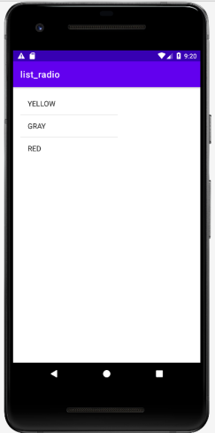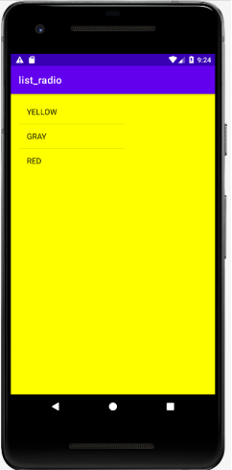

C)Relative Layout
Fragment Dialog:

Step:
- Res->layout->new->resource file->file name
- Java->package->new->Kotlin class/file->name->enter
Resource file:
<?xml version="1.0" encoding="utf-8"?>
<RelativeLayout xmlns:android="http://schemas.android.com/apk/res/android"
android:layout_width="match_parent"
android:layout_height="match_parent">
<EditText
android:id="@+id/edit"
android:layout_width="match_parent"
android:layout_height="wrap_content"
android:hint="Enter Name" />
<Button
android:id="@+id/button"
android:layout_width="wrap_content"
android:layout_height="wrap_content"
android:layout_below="@+id/edit"
android:text="Submit" />
</RelativeLayout>

Class file:
package srm.it.fragment_dialog
import android.os.Bundle
import android.view.LayoutInflater
import android.view.View
import android.view.ViewGroup
import android.widget.Toast
import androidx.fragment.app.DialogFragment
import kotlinx.android.synthetic.main.resource_file.view.*
class myClass:DialogFragment (){
override fun onCreateView(
inflater: LayoutInflater,
container: ViewGroup?,
savedInstanceState: Bundle?
): View? {
var s=inflater.inflate(R.layout.resource_file,container)
s.button.setOnClickListener {
var data=s.edit.text.toString()
Toast.makeText(context,"$data",Toast.LENGTH_LONG).show()
}
return s }}
mainActivity:
package srm.it.fragment_dialog
import androidx.appcompat.app.AppCompatActivity
import android.os.Bundle
import kotlinx.android.synthetic.main.activity_main.*
import kotlinx.android.synthetic.main.resource_file.*
class MainActivity : AppCompatActivity() {
override fun onCreate(savedInstanceState: Bundle?) {
super.onCreate(savedInstanceState)
setContentView(R.layout.activity_main)
button2.setOnClickListener {
var obj=myClass()
obj.show(supportFragmentManager,"hello")
}
}
}

Output:

